**Assignment –**

**4DockerandKubernetes**

|  |  |
| --- | --- |
| Assignment Date | 02November2022 |
| Team ID | PNT2022TMID50737 |
| ProjectName | Inventory Management System For Retailers |
| Maximum Marks | 2 Marks |

**Question-1:**

Pull an Image from docker hub and run it in docker playground.

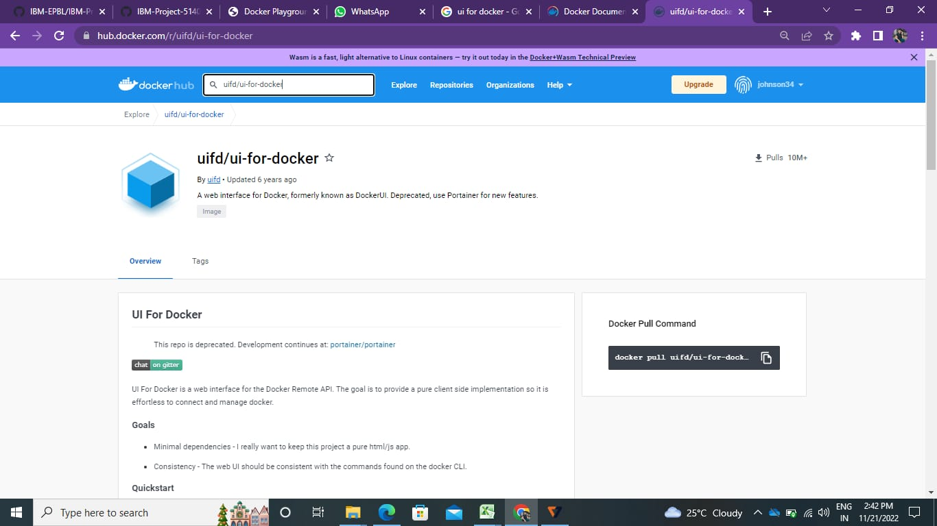

**Pulling and viewing the image in the command line of our docker playground interface:**

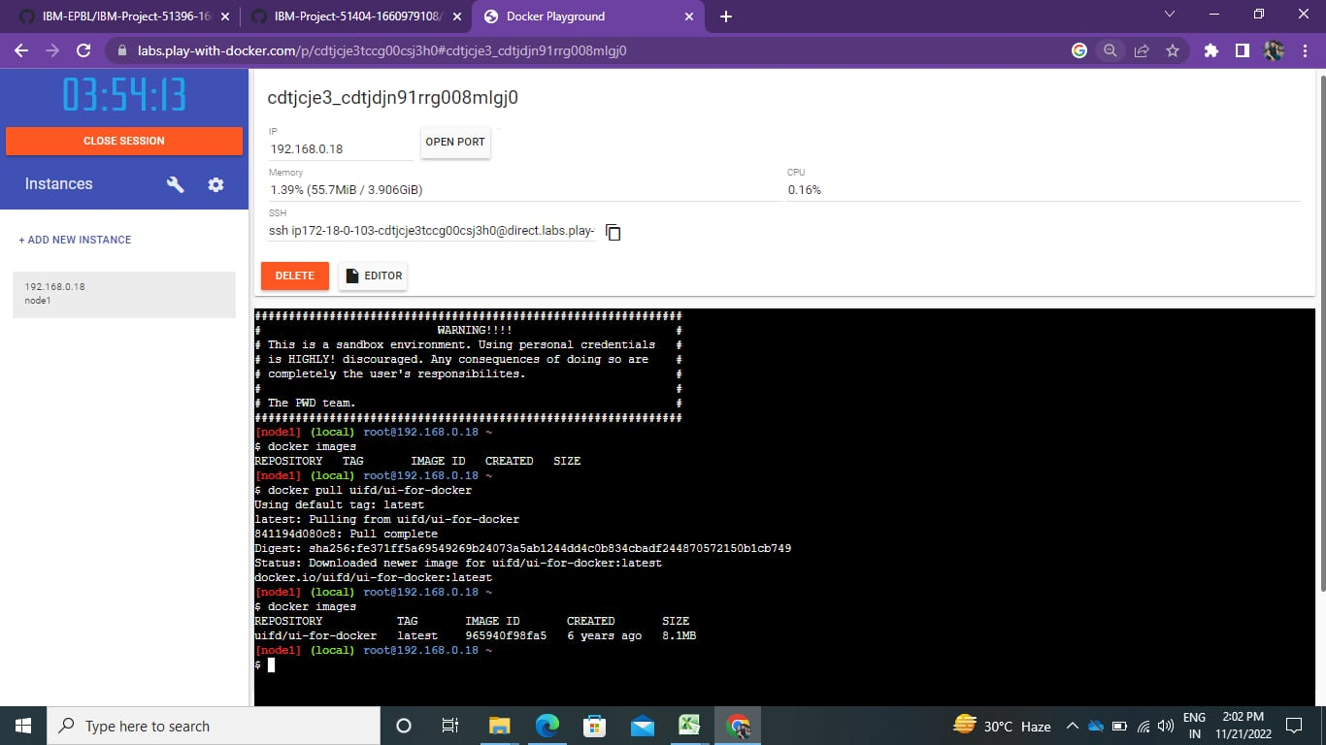

**Running the image, (command and the output side by side)**

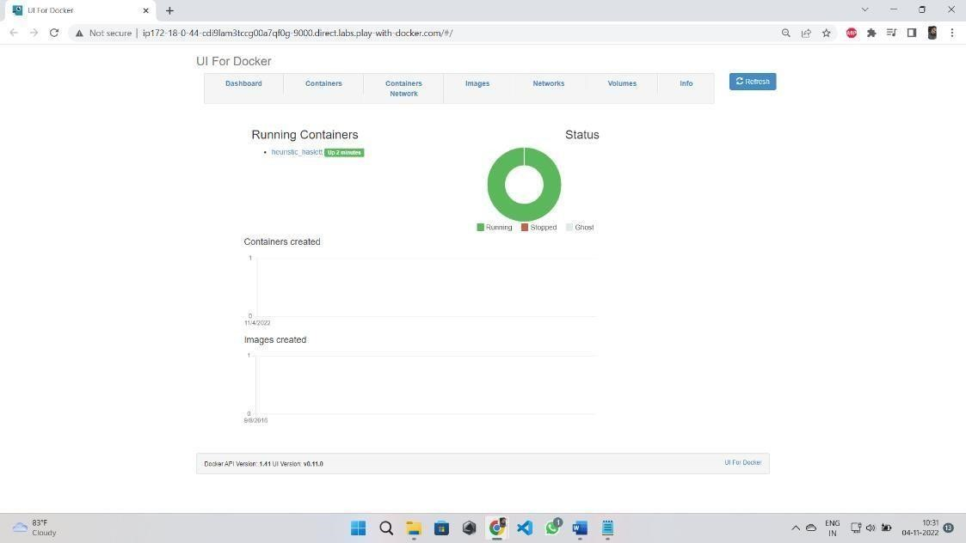

**Question-2:**

Create a docker file for the job portal application and deploy it in Docker desktop application.

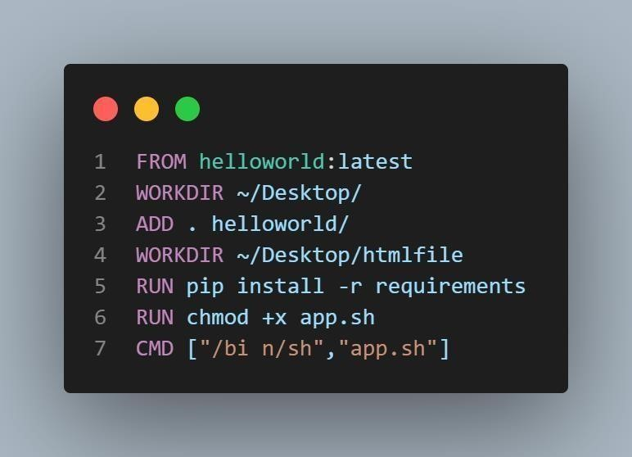

**Question-3:**

Create a IBM container registry and deploy hello world app or job portal app.

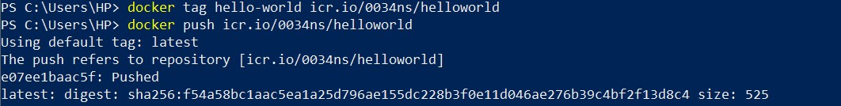

**Question-4:**

Create a Kubernetes cluster in IBM cloud and deploy helloworld image or job portal image and also expose the same app to run in node port.

